How to Create an Account on WCOnline
1. Go to www.ucalgary.mywconline.com
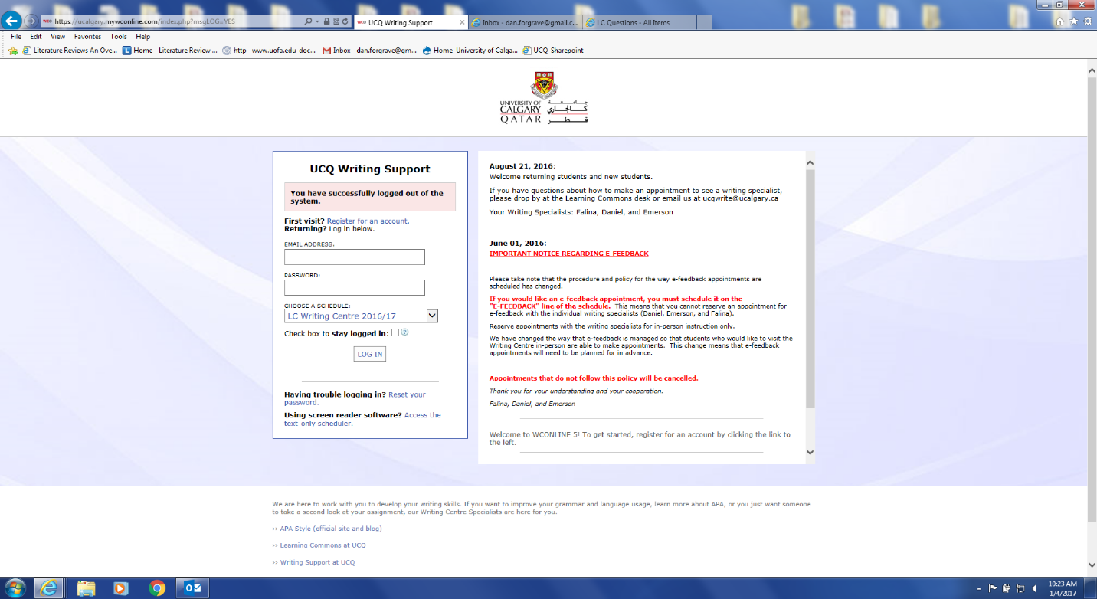
2. Click on “Register for an account.”

3. Fill out the “Create a New Account” form. Use your UCQ email address.
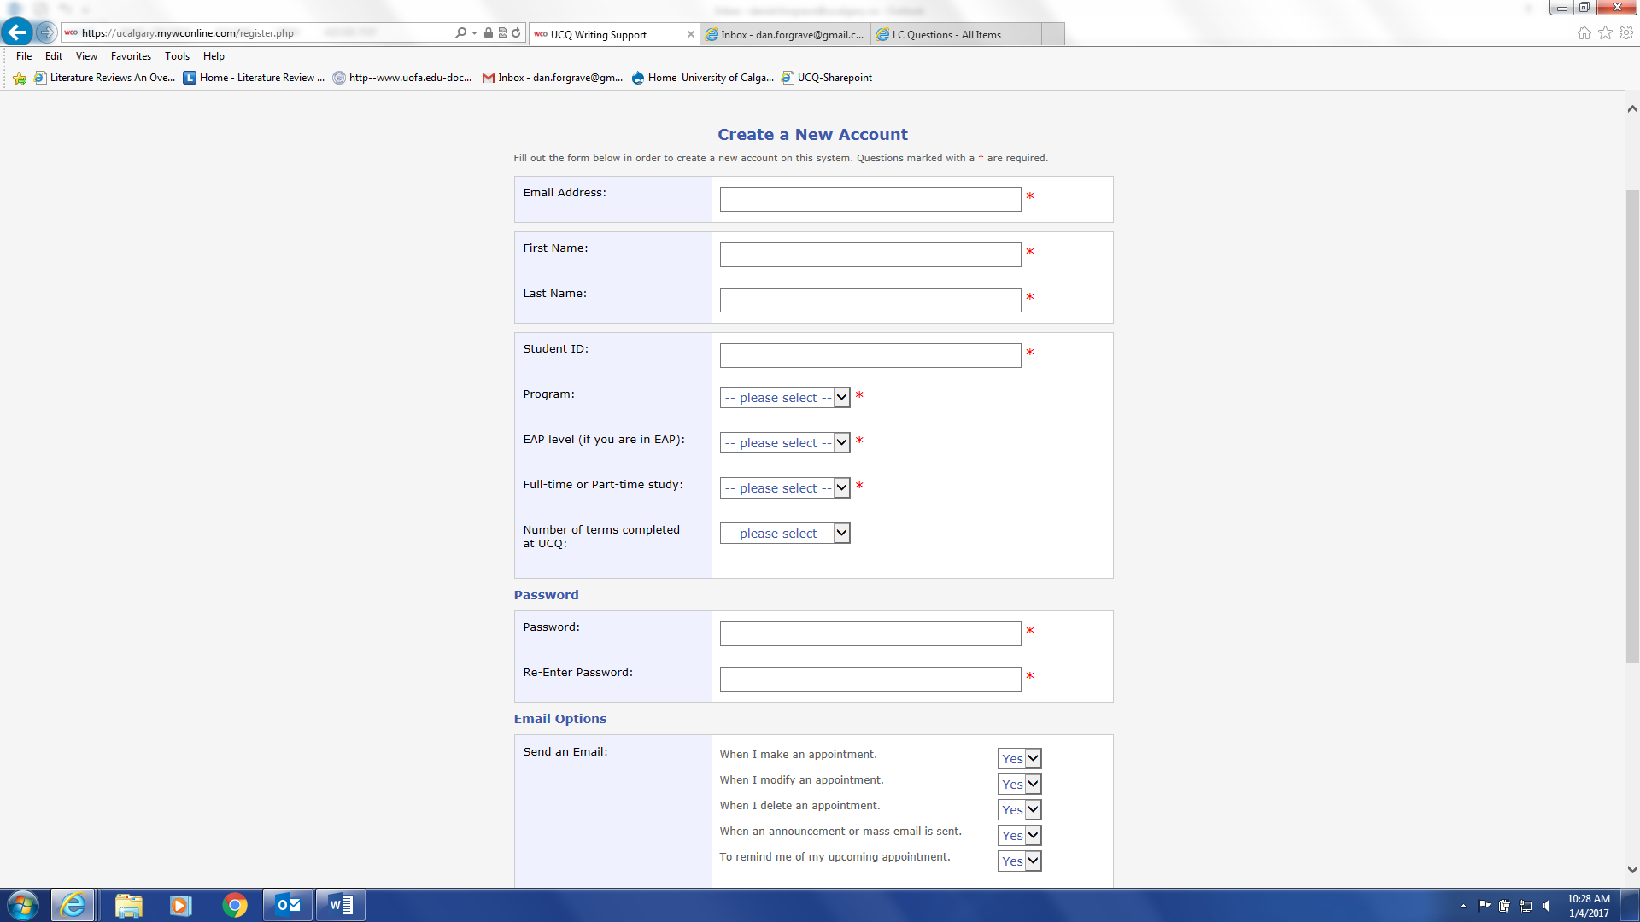

4. Finish filling out the “Create a New Account” form. Use a password you can easily remember. Save the password on your phone in case you forget.
Click “Register” when you have completed the form.
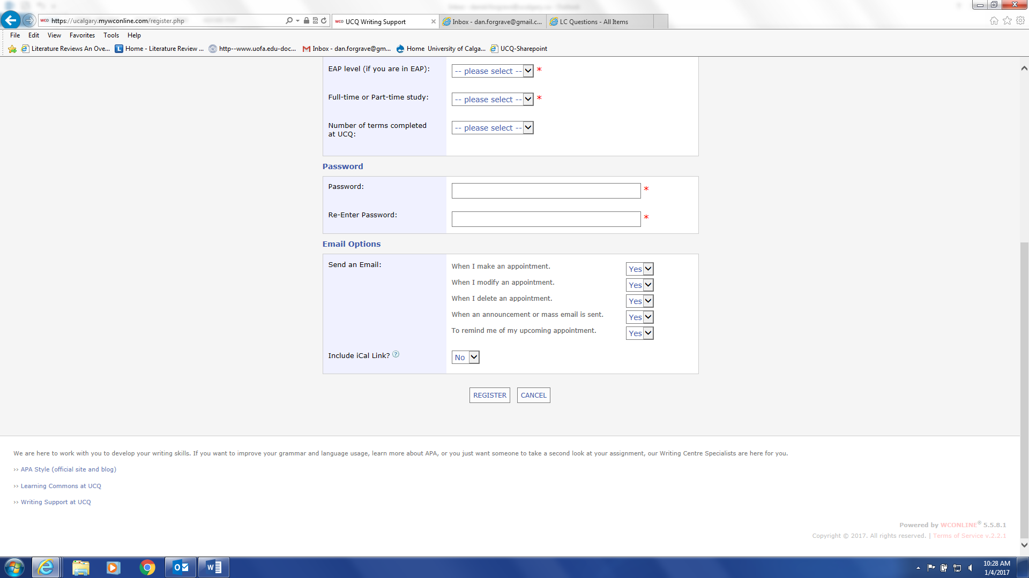

How to Make an Appointment in WCOnline

1. Go to www.ucalgary.mywconline.com
2. Enter your username and password.
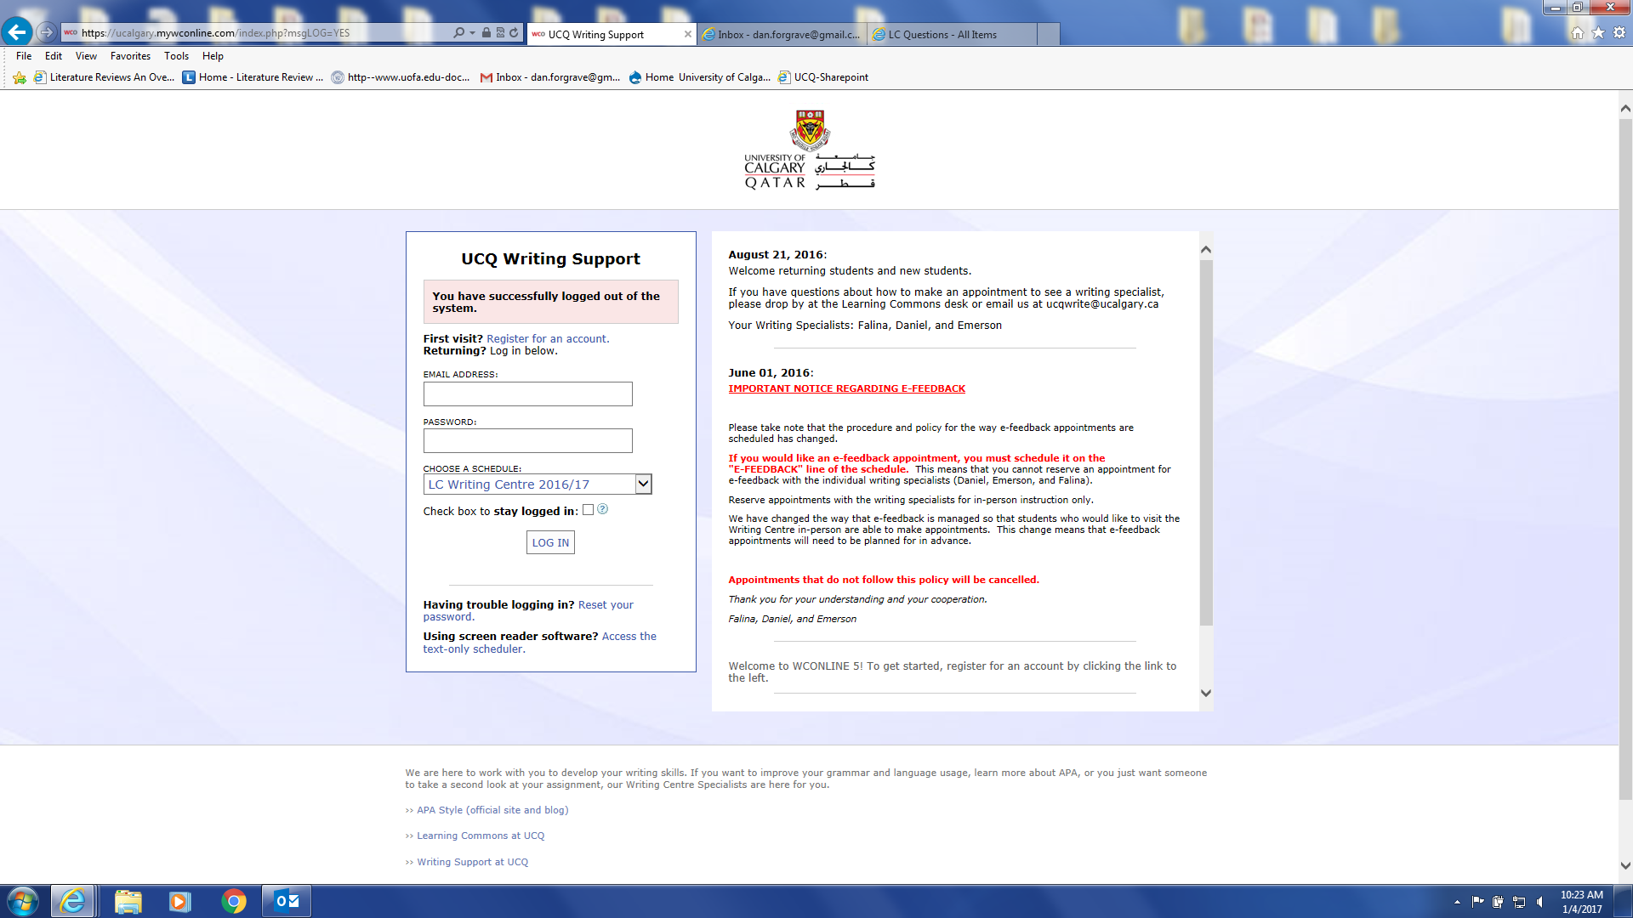
3. Click on “LOG IN.”

4. Choose the date you would like to have an appointment.
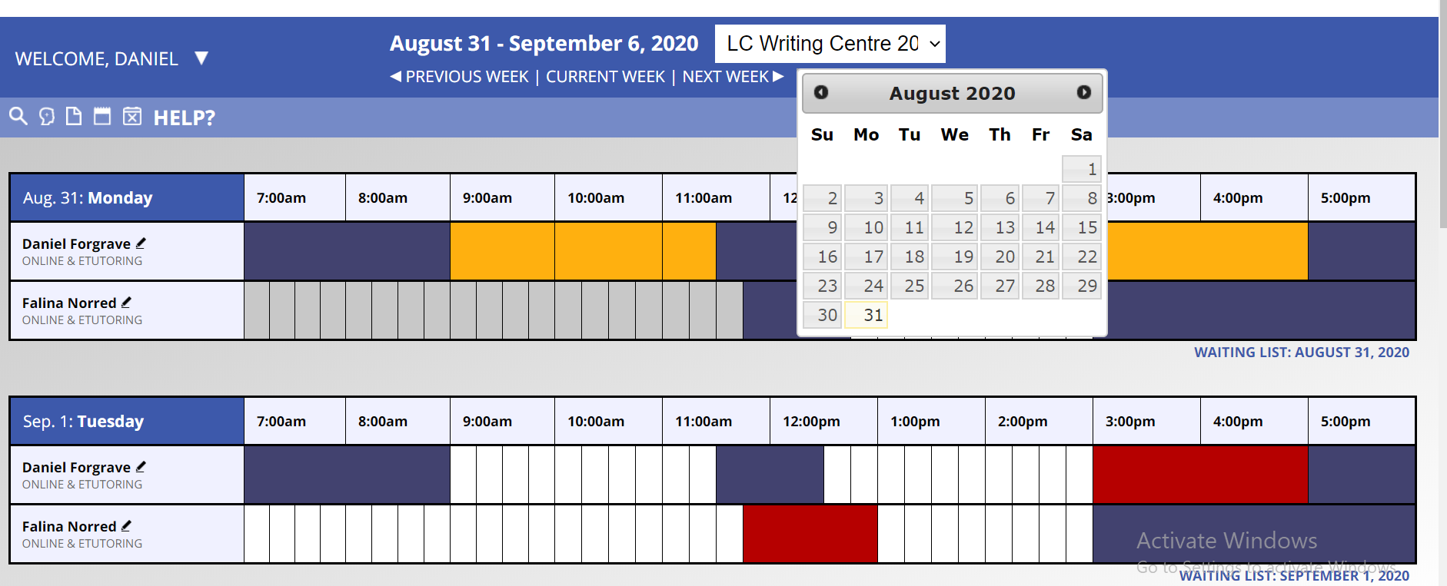

5. Choose the LC Writing Centre 2021/2022 calendar for appointments with a Writing Specialist or the Librarians’ Schedule 2021/2022 for appointments with a Librarian.
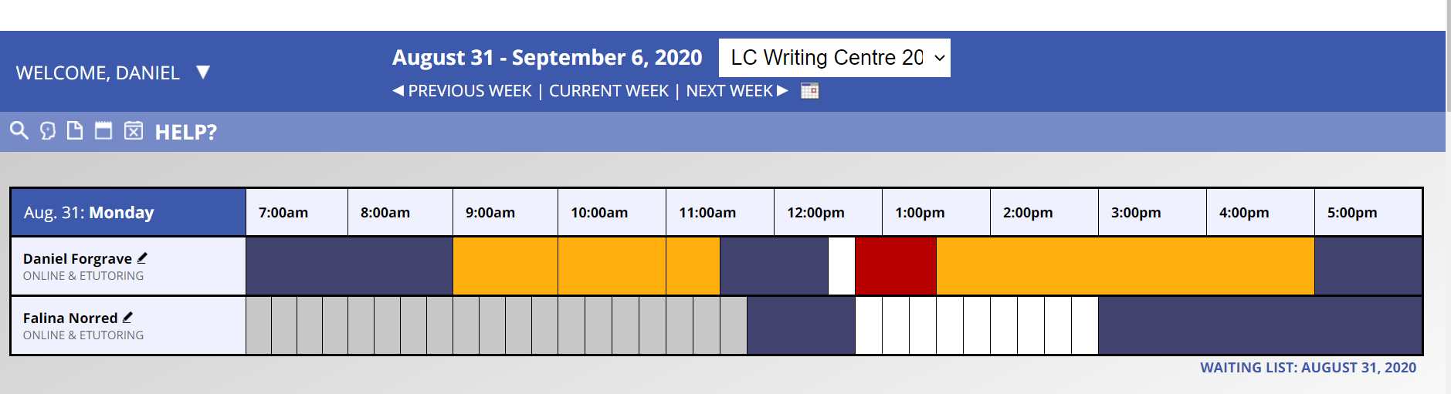

6. Choose the Writing Specialist or Librarian you would like to see for your appointment.

7. Choose the time you would like your appointment to begin and click on that space. You can only book appointments in squares that are white.

8. Fill out all information in the appointment pop-out box.
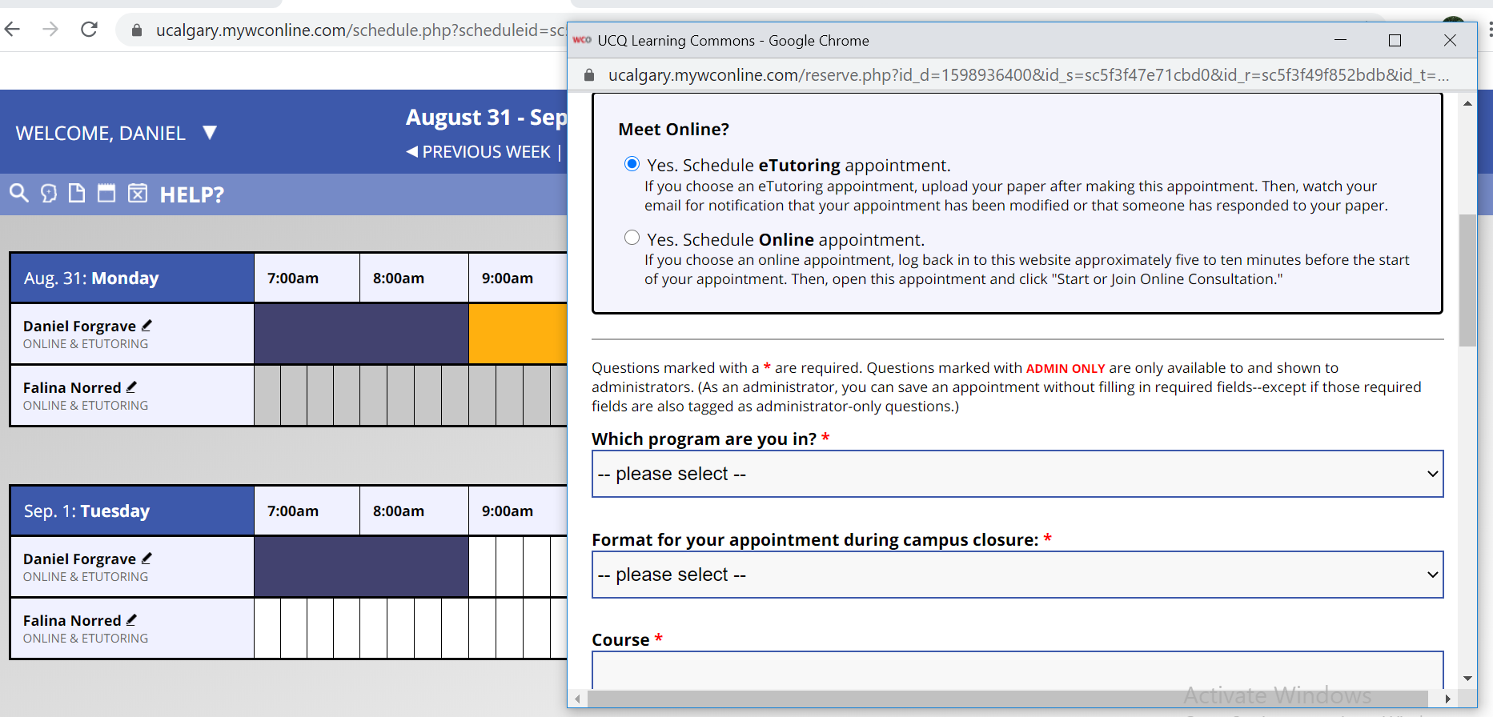

9. Click on “CREATE APPOINTMENT.”
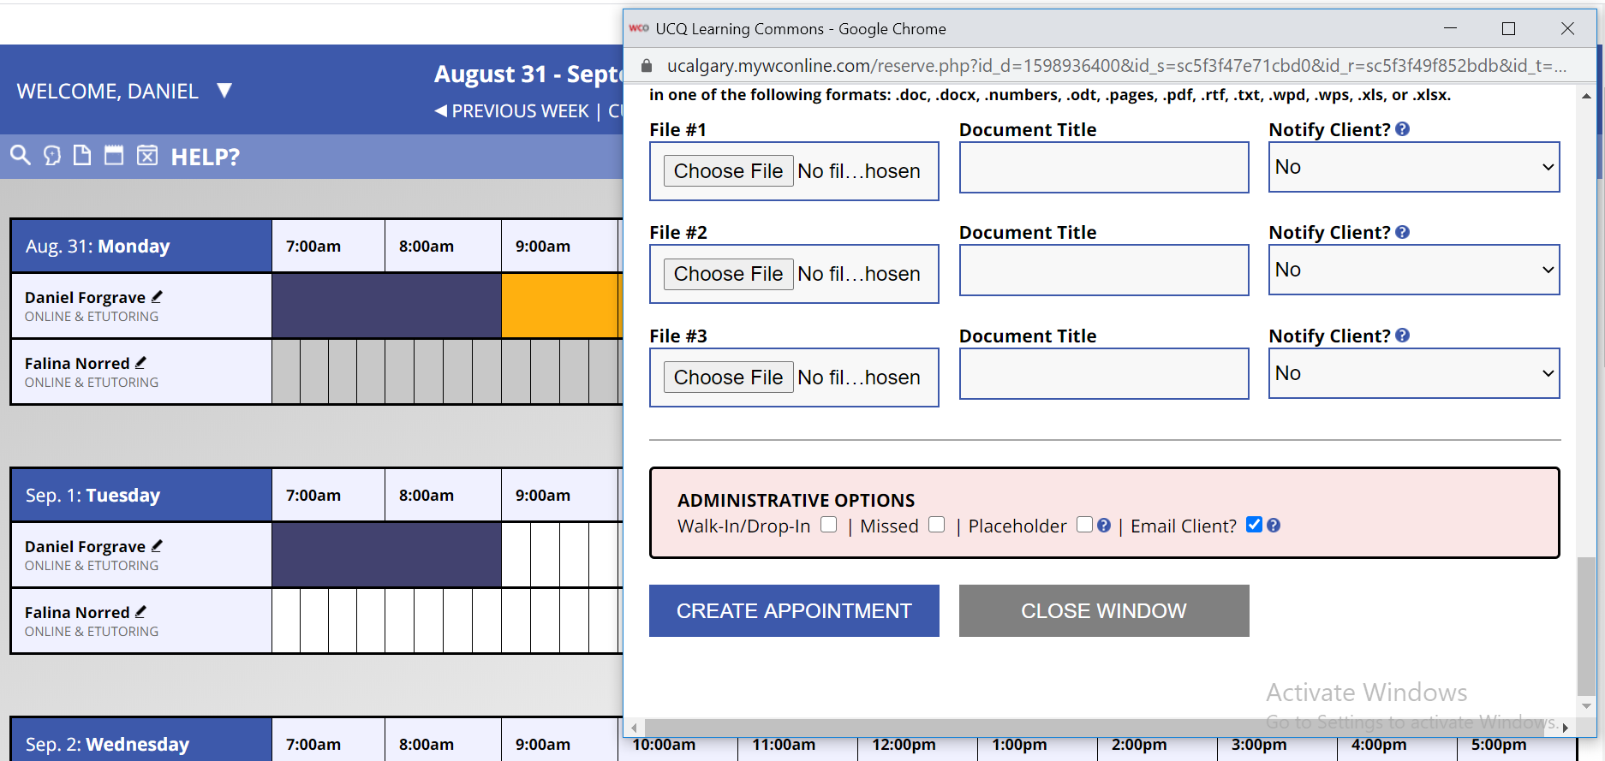

10. Your appointment will appear in yellow in your WCOnline calendar.
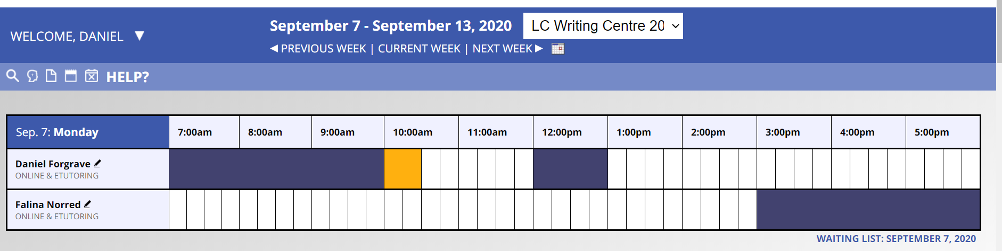

11. Write down your appointment time in your personal calendar (either paper or electronic).

12. Attach your assignment / document to the appointment at least one hour before your appointment.
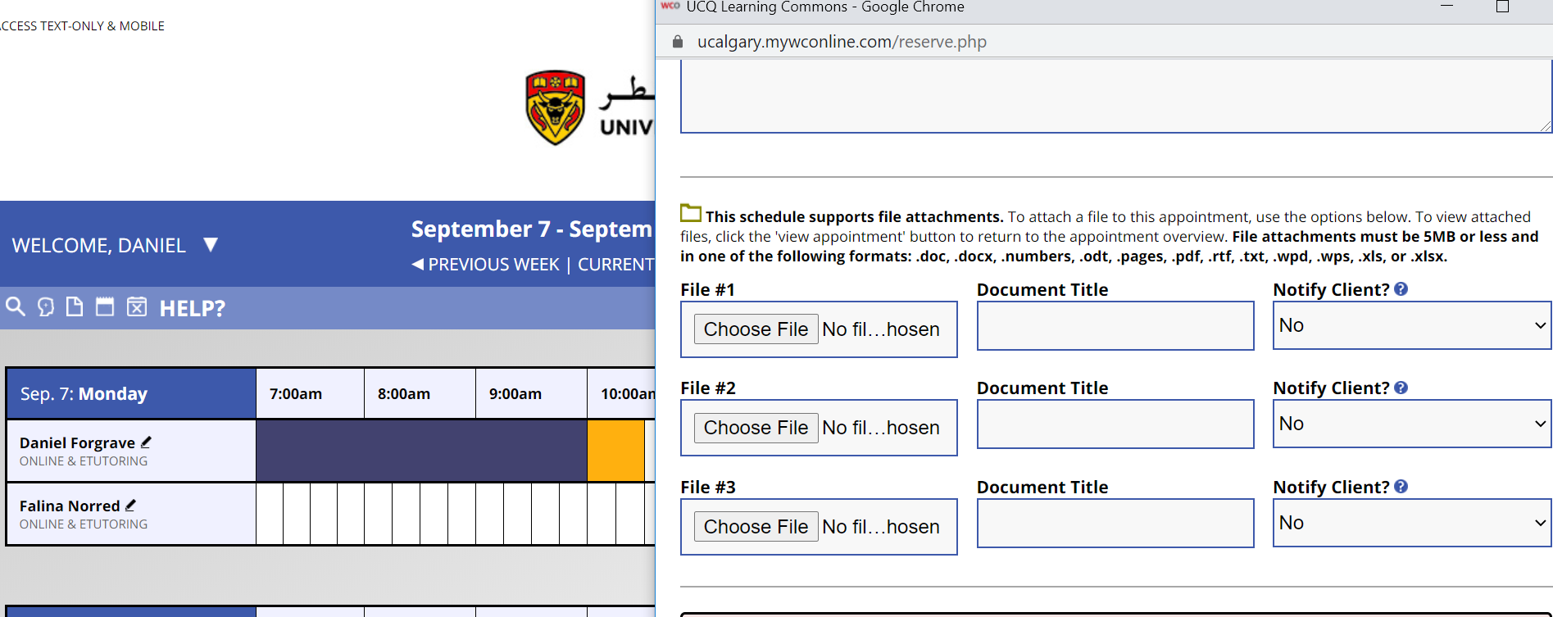

How to Join the Waiting List in WCOnline

1. Log on to www.mywconline.com
2. Click on “WAITING LIST”below the date you would like to have an appointment.
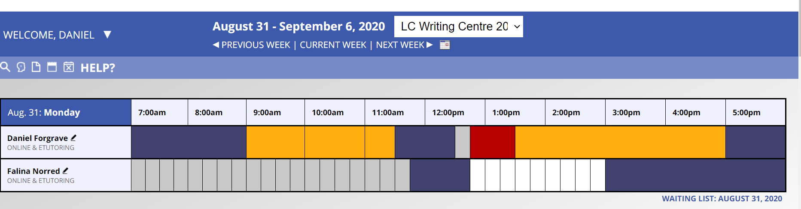

3. Complete the information in the pop-up box and click “JOIN THE WAITING LIST.”
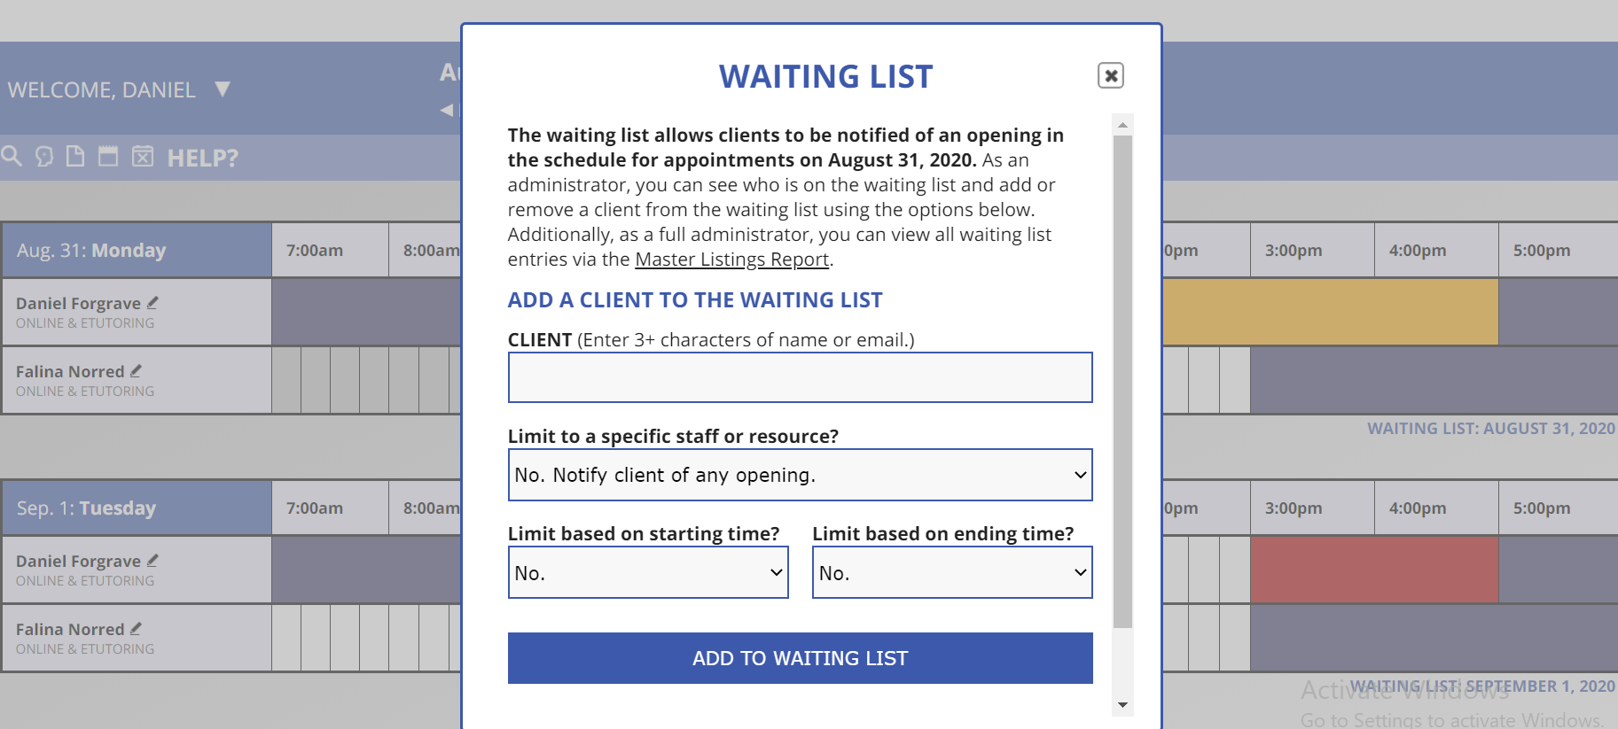
4. WCOnline will send you an email if a cancelation happens. It is your responsibility to log in to WCOnline to make the appointment. WCOnline will not reserve appointments for you.

